The University of Newcastle

School of Electrical Engineering and Computing



Work Integrated Learning

COMP3850 / COMP3851A – Semester 2, 2019

**Interim Report**

*Authors:*

GARTH VASSEL

KIRANJOT KAUR

LAKSHYA

TOBY TUMSITHI

NOV 07, 2019

1. **Project Title**

Stealing The Future: Designing, marketing and commercializing a functioning 2D game based on ‘Metroidvania’ genre with a unique story, original art and music.

1. **Background**

* Team background:

The project will be created by a group of 4 members as a work-integrated project towards the course COMP3851A. The project will cover all the aspects of Bachelor of Information Technology i.e. the project will utilize all majors (Systems development, Interactive media and Business technology) as a part of its fruition considering the backgrounds of all participating members belongs in all these majors. The chosen project is developing a video game, marketing it on all digital platforms and selling it for financial gains.

* Game mechanism and layout:

The game will be in a 2-dimensional environment following the mechanism of Metroidvania (Wahlberg, 2015) (sub-genre of action-adventure games). We have decided to work with a villainous protagonist who acts on well intentioned but morally reprehensible terms. The game design will be non-linear and will allow the user to explore the interconnected world by unlocking ways of progression by acquiring items and upgrades. The game will have unique storyline, art frames, music, character design and game design that will be created by the team. On completion, the game will be set out for digital marketing and cost collection by making it available on platforms such as steam and game’s very own website.

* Competitors/similar products and difference between our products:

Iconoclasts (Bifrost Entertainment, 2019) is one such game where the environment of the game is controlled by an oppressive religious government. The protagonist is a falsely accused mechanic whose father was executed by the government for not having a license to practice. The game revolves around her escaping and fighting her way by solving puzzles.

Another game named Hollow Knight (MILNER, 2018) works on a similar mechanism. It is a bug themed game where our protagonist explores an underground world while exploring the story by paying the game. The story can be missed if the world is not explored thoroughly due to the fact that the game does not explain the story in cutscenes.

Axiom Verge (Edge, 2016) is one more game that explores the gameplay of Metroidvania design by designing the game on a pixel-based format that old Metroidvania games used to do. The gameplay incorporates the glitches in the old games in their gameplay and allows the player to abuse them in order to clear the levels. But the design and art style does not work for people who have not indulged in such games previously.

The noticeable difference between our product and this game is that our protagonist is going to be a villain rather than a hero. Secondly, the environment in our game will be dictated by the protagonist and not by some corrupt organization/ruler. Thirdly, the game will have combat and puzzles in balanced amount instead of simply dedicating it to either one of them. Fourthly, the game will have cutscenes so that the essence of the story is maintained throughout the game experience. Lastly, our game design will have art design and music that allows all generations to enjoy the experience and understand the gameplay easily.

1. **Aims**

* To create an original storyline for the game:

Our goal is to write our own unique story and integrate it into the game. We would be narrating the scenario of the game from an anti-heros perspective for a unique gameplay experience that will hopefully engage our audience. We would implement the other skills we’re learning into this process such as video making and voicework.

* To create a unique engaging gaming experience:

We hope to implement by the end of the year a phase one part of the game. We hope to create the start of the story and perhaps one area of the city for the player to explore and be challenged. We would like to create a series of levels, challenging platforming puzzles a HUB area for the player and a boss fight or two.

* To create a world that feels larger than the scope of the game:

Another goal of ours is to create a game world that feels like it is larger than the immediate story.

To do this we will make use of multiple different facets of design from audio, visual, and

textual information in order to create a game world that feels living and inhabited.

* To create original music and sound work for the game:

Another one of our goals is to create some original background music for our levels inside the game, as well as special effect noises and some vocal work for our in-game cutscenes. We hope that we can enrich the users experience with unique tracks and dynamic sounds.

* To create video content for the game:

We will create video trailers, cutscenes, opening and ending videos for our game. The process will be undertaken with respect to the storyline of the game and to provide user with a thrilling and exciting experience.

* To create original art and assets for the game:

We would like to implement into our game original artwork and designs of our video game world. Including areas, characters and monsters by inheriting inspirations from existing contents out there as well as new creations from our own mind.

* To create marketing content such as webpage, social media accounts & trailer for the game:

We would like to advertise our game to the point where we would like to push it for commercial sale. To accomplish this, we will create a website with information about our game, latest updates, blog posts and ways to pre-order and purchase the game. We would also like to create a video trailer to advertise the game so it can reach a wider audience.

* Skills improvement:

One of our weaknesses is that a lot of this stuff is either new to us or we’re not that experienced. Throughout the project, we would like to improve upon all of these areas such as design, sound, video editing and programming. All of which this game demands us off, so as a result of this project we would like to improve our skills for the future.

1. Methods

* Storyline, characters and the world:

We created a high concept document for the project entailing some groundwork for the story where we outlined key elements for it. Additionally this document includes notes on other world building aspects such as notes the player might find around or environmental storytelling in the assets which makes the world feel larger and alive

* Game prototype:

We created the basic principles and groundwork for our game. We used the unity engine to create a baseline of our game and we intend to continue to use this for the remainder of our project. Furthermore we’re currently watching and learning from Unity Learn and other online sources to teach us C# to integrate into our project.

* Audio design:

We have chosen to make a synth-heavy soundtrack to fit with the futuristic feeling of the game. In terms of sound effects, they are highly dependant on what the effect is for. We are using FL studio for the game music, and are using bfxr in combination with audacity for our sound effects.

* Art design:

Concept art for marketing and game art was a crucial requirement for game design. We had to design character sketches, concepts, area designs and backgrounds for the game. In order to do that, we had to take inspiration from outside sources. We studied many existing metroidvania games to understand the art layout. For concept art, we took random photographs and created a cyberpunk theme out of them and transformed the image into pixel art by using Adobe Creative Cloud (Photoshop and Lightroom for now). The process included getting familiar with the Adobe software and environment and understanding the theme dynamics of cyberpunk.

* Website design:

In order to reach out to our potential audience, we decided to develop a website where all the content regarding our game is available. We used an external website development service ‘Wix’ to create our website. The website contains all the concept art, product information and the product itself(in future when available).

* Self learning

For sound design we had to learn some digital audio workstations to create the sounds. We learned how to use FL studio to create the music for our game, and learned how to use gfxr in combination with audacity to create sound effects and apply equalisation and other effects to the sounds.

For the actual game prototype we utilized unity and paid for a subscription to unity learn to follow online tutorials to teach us about basic game mechanics. We used these skills to build a basic prototype for the presentation.

1. Results

* Storyline, characters and the world:

Example mission text is below:

“The Rat’s nest. An ugly name for a neighbourhood, but a lesson in the results of corporate greed. No law operates here but the rule of gangs, trying to carve out a modicum of survivability amidst the run-down buildings and overgrown gardens.

Gang ruled as it is, there is still a growing community here. Those disenfranchised or otherwise unable to live elsewhere in the city congregate here, protecting themselves and each other from the cold and from hunger.

This could all change for the better. “

*“Crash*. The nightclub’s name didn’t make sense until you entered; opening the sound-proofed doors is like running headlong into a wall of light and sound. The strobe lights assault your eyes and the air is heavy with a sickly sweet mixture of perfume, alcohol, and cigarettes. Yigil knows you are here already and is already hunting you down as your senses are assaulted by the club. You quickly check over your equipment once more and steel yourself to enter *Crash* and lose your pursuer.”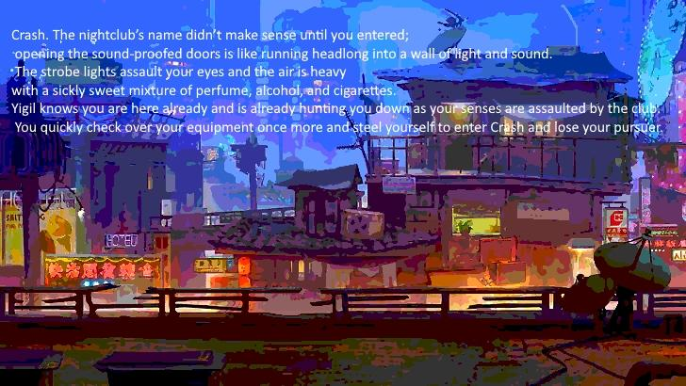

Figure x? above shows what a loading screen with mission text may look like.

* Game Prototype:

The screenshot from figure ? showcases our prototype from unity. Currently in our prototype you can see our basic user interface of the game and the in-game art assets we have created from other softwares implemented into the game. Currently we have a character model, a background image, some collectibles, a tileset and some environment interactables. See Figure ? for a preview.

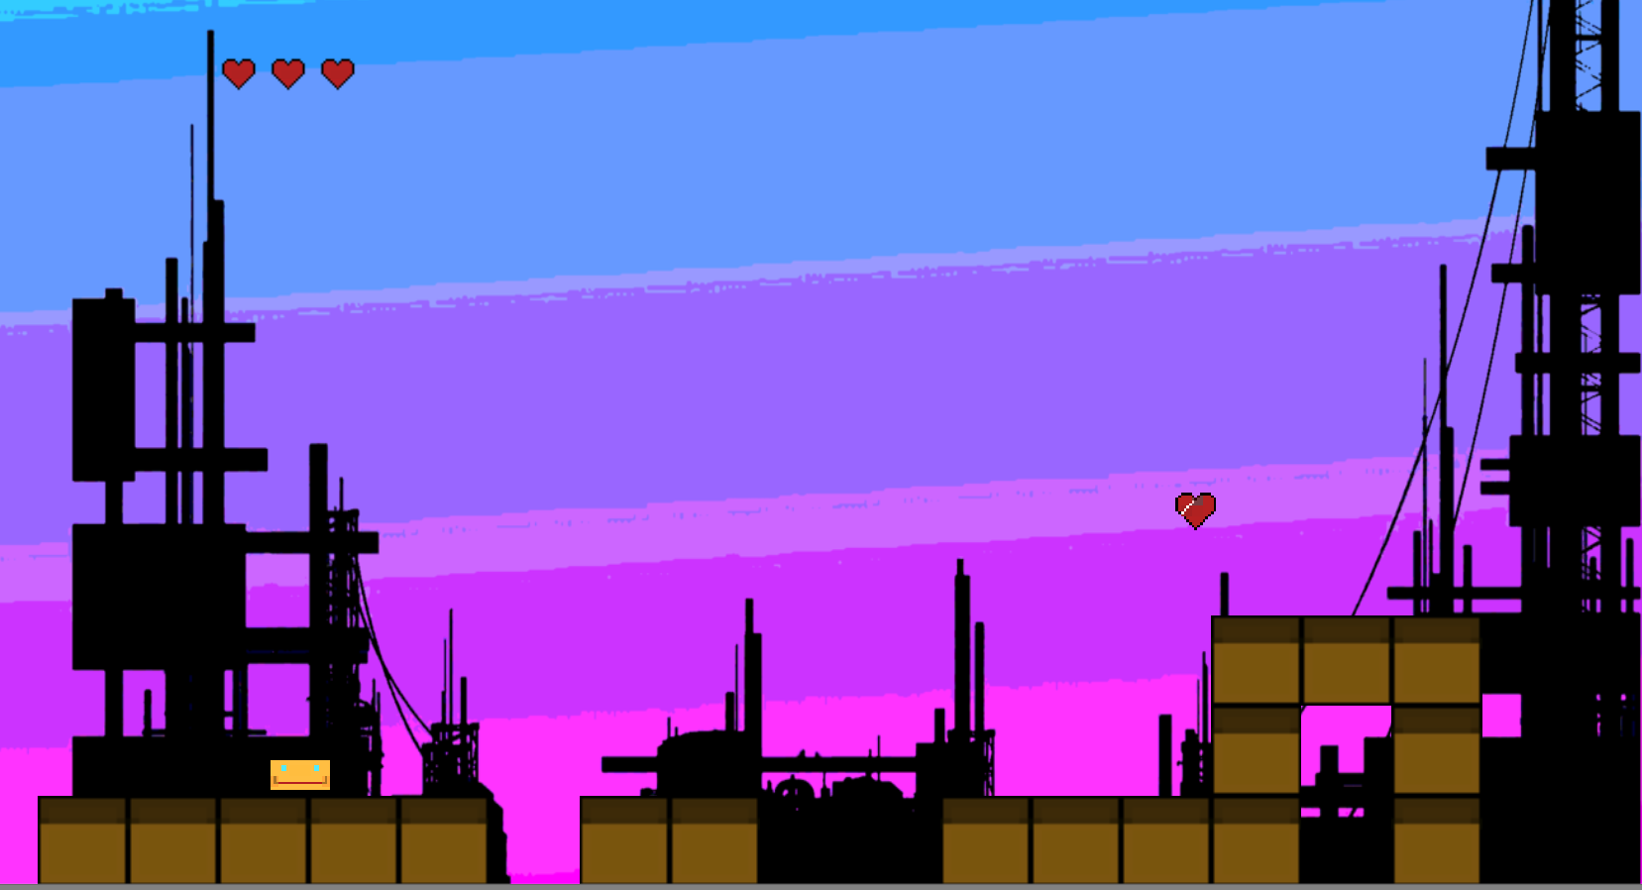

*Figure ? - This screenshot is of our game prototype, it features the foundations of our games UI.*

* Audio design:

The screenshot below comes from FL studio and is of an audio snippet of synth music. It utilises the difference capacities of FL studio such as sending tracks to different channels for effects to be applied, equalisation of patterns, and automation of different effects.

* Video content:

Due to the amount of self learning and other creative work we had to create, the video trailer/cutscenes are not completed at the time of this report. We still would like to achieve this objective and we have made choices on what software to use and what we’d like the videos to look like however there's no physical showcase of this yet.

* Art content:

We used Adobe CC to create our logo, website backgrounds, concept arts and the game backgrounds. We were able to retouch some stock photographs and make them cyberpunk themed followed by editing them to give them pixel art theme. The background for the game prototype was created by gradually fading a colour and pixelating it followed by overlaying it with silhouette of buildings to blend along with the assets. See the following figures for examples of this.

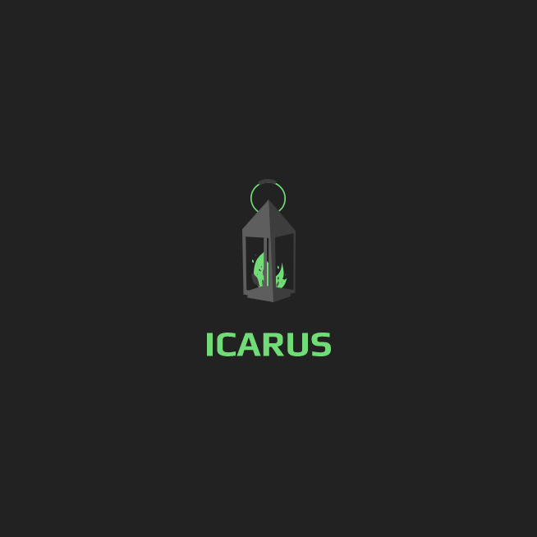Figure ?. Logo

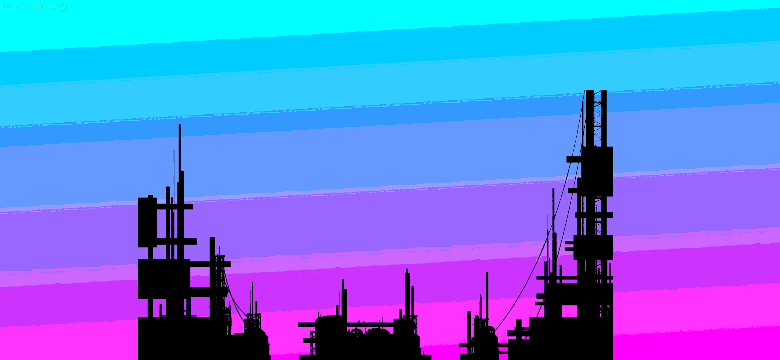Figure ?. Background Prototype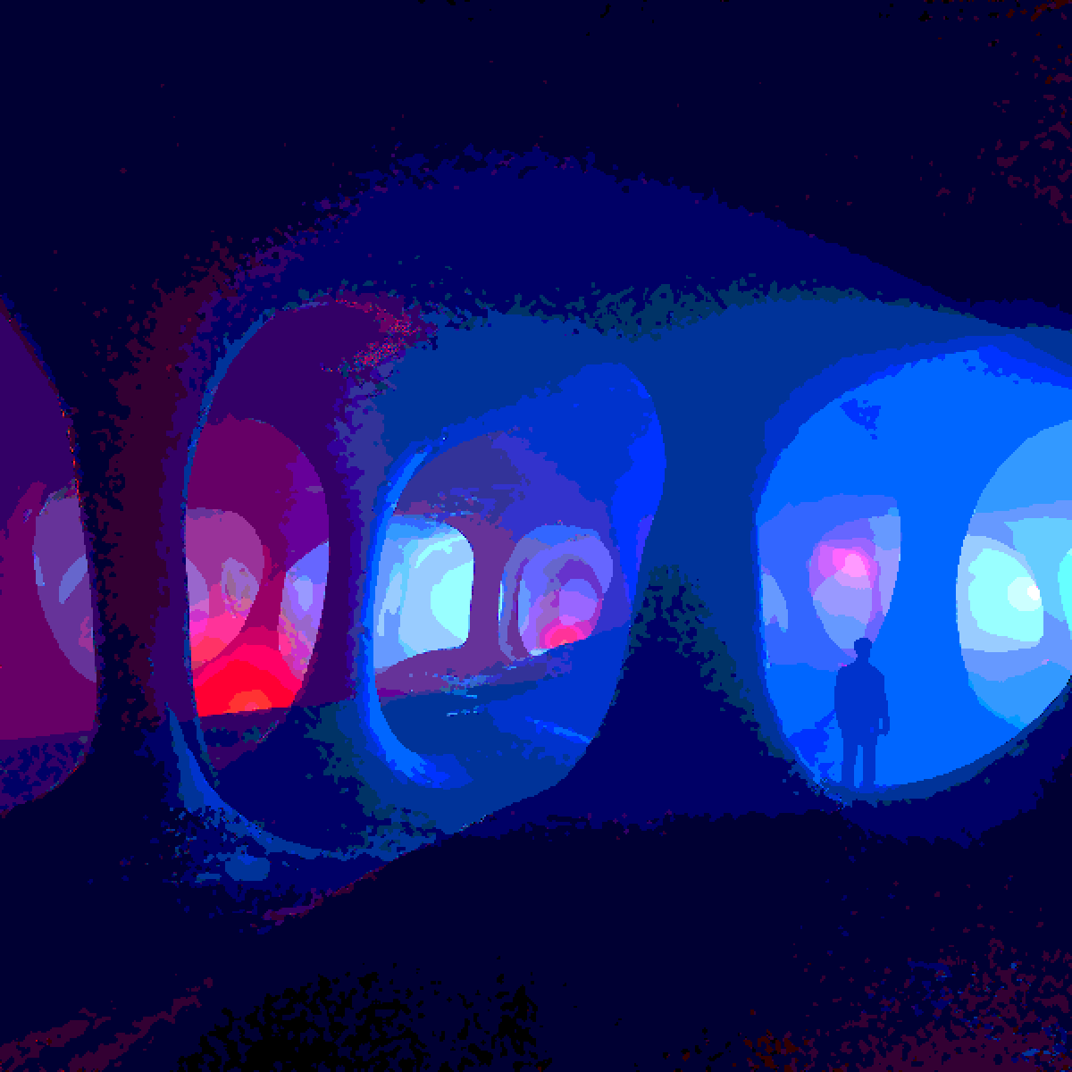Figure ?. Concept art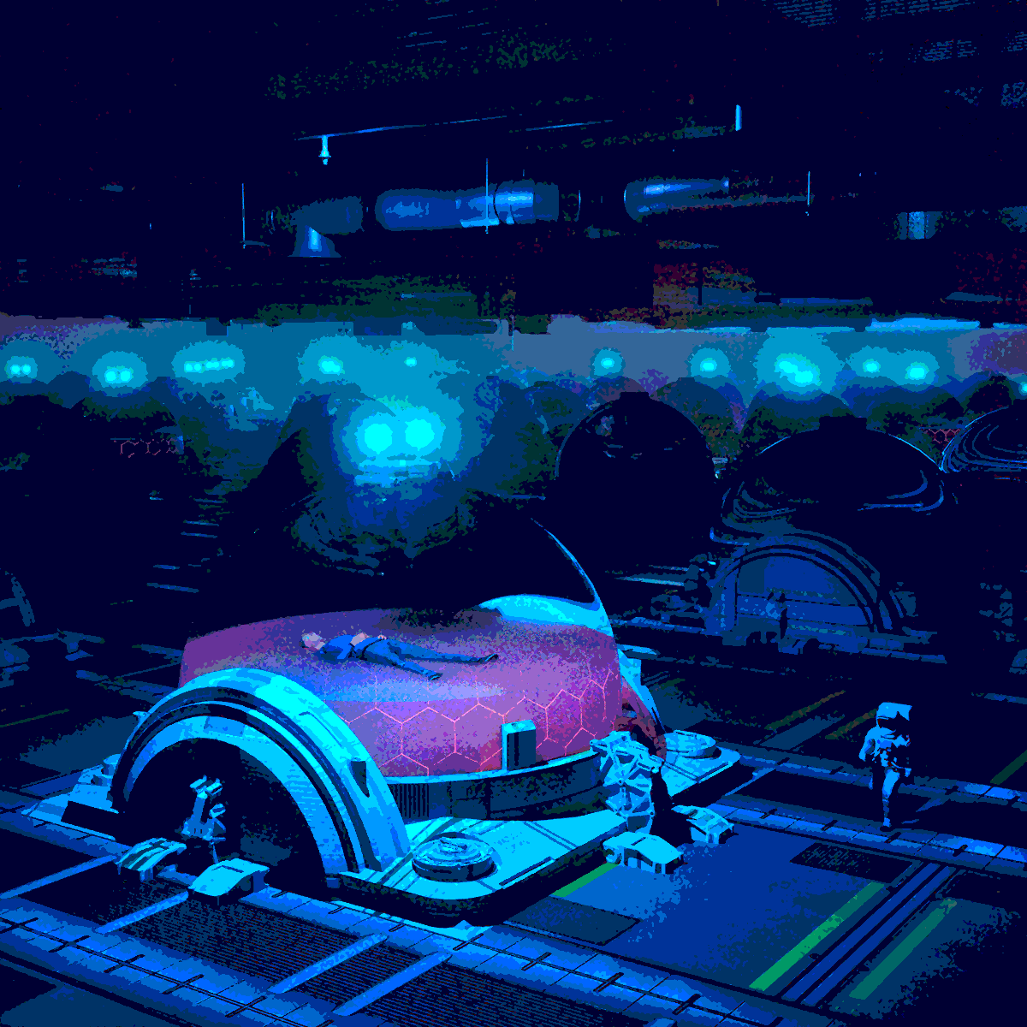Figure ?. Concept art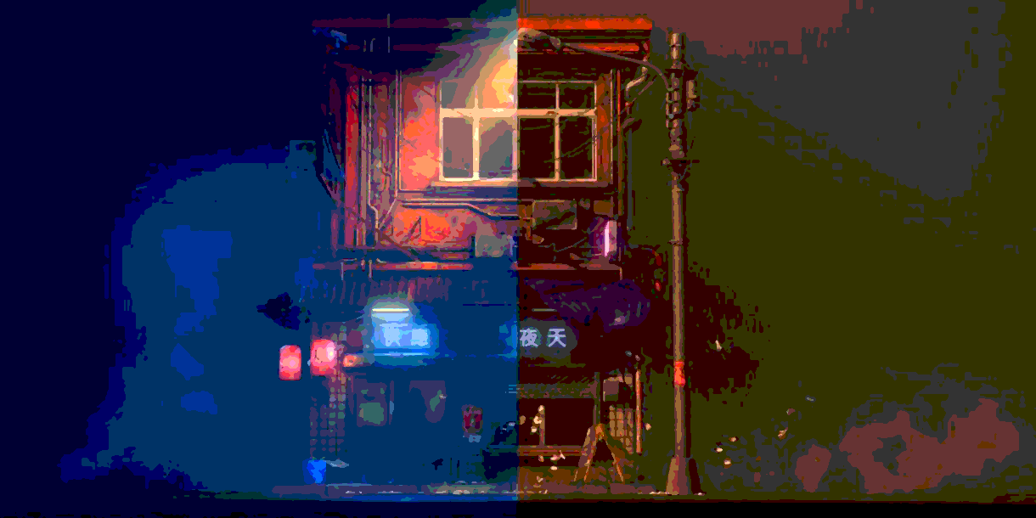Figure ?. Concept art

* Website content:

The website is unpublished yet due to lacking content. As of now, the website contains a home page describing ourselves as a group of university students. It also has a community engagement panel where we can get feedback from interested individuals regarding anything they want to say. The website also contains links to our social media platforms (yet to be customized) and an option to purchase the product (product yet to be added).

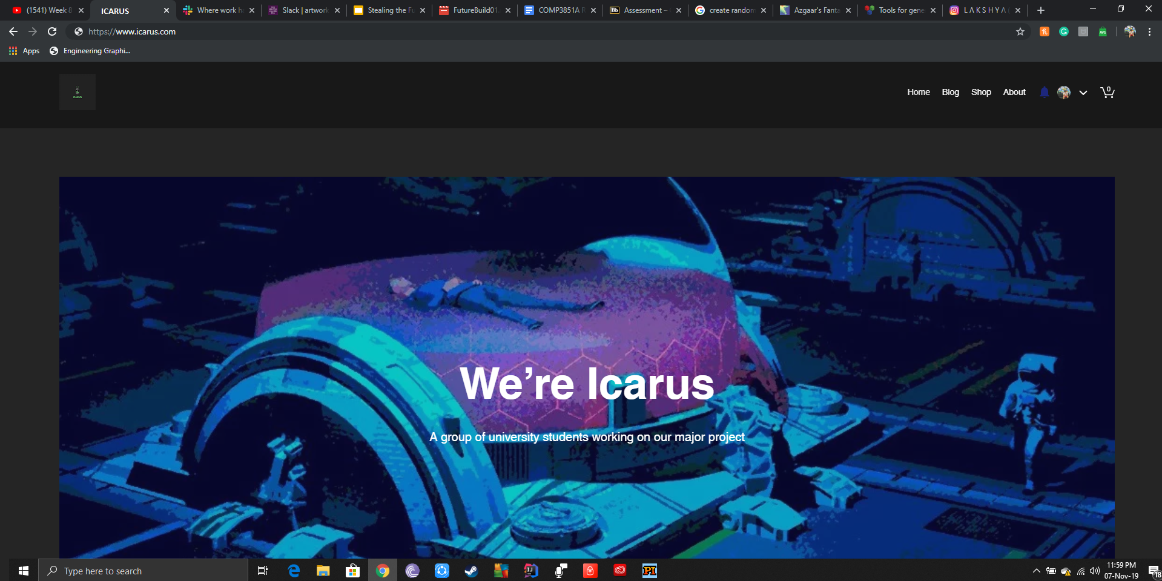Figure ?. Website Homepage with options to browse through blog, shop and about us pages.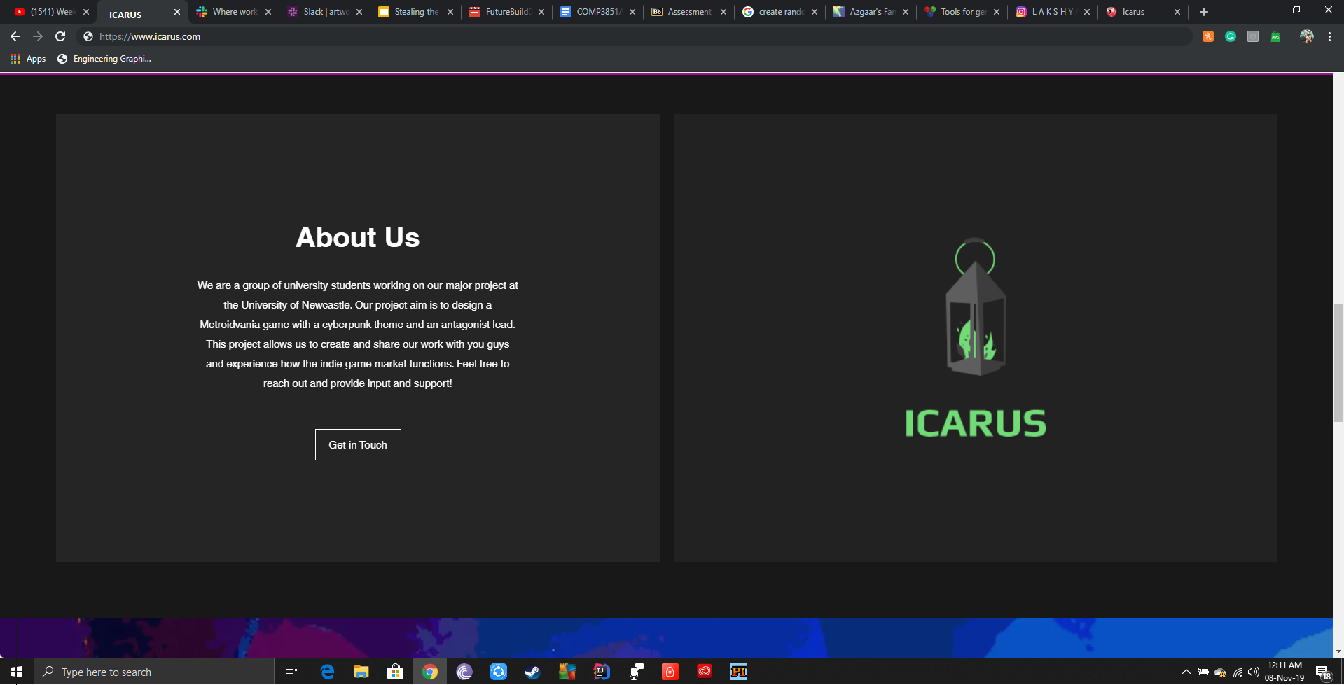Figure ?. About us section on the website

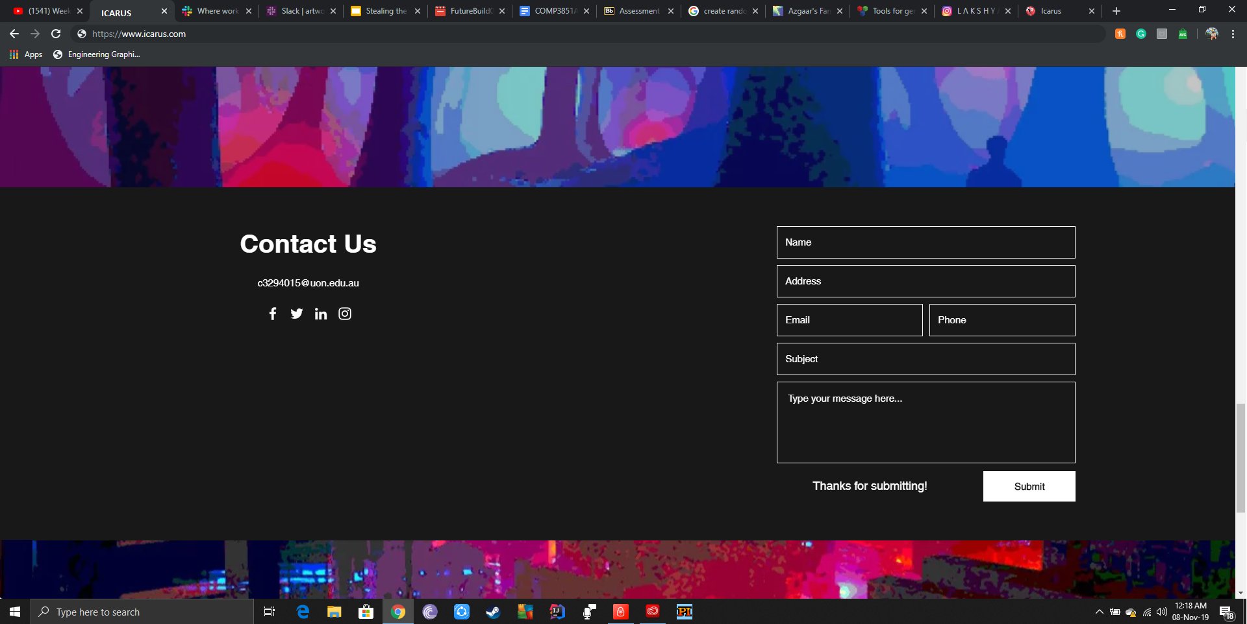Figure ?. Contact us section on the website

1. **Ethics considerations**

* Diversity and discrimination:

Many video games lack diversity in terms of gender and race. Many games are dominated by men, even though many gamers are women. Women are presented as characters in mainstream games. Some games have a main character as a man having big muscular hands and legs. (En.wikipedia.org, 2019). Also, women are portrayed nude in some games and the majority of players are under 18 years of age. We will consider these diversity issues while designing the game.

* Special needs consideration:

Previously created video games were not accessible by the disabled and illiterate people. Later in the period, the accessibility of video games has received some mainstream research attention especially for players with sensorial disabilities. (Earp (2018)) Modern game designers implement beneficial design strategies for disabled players, thus improving the gaming potential. Considering this, we will develop our game with a wide range of accessibility features such as high visibility graphics, colour-blind friendly.

* Copyright issues:

Copyright law does not protect ideas; only actual expressions that have come into being as some object or tangible property. Although the artwork creating specific character and words that comprise the game dialogue are protected by copyright, the basic game concept is not protected by copyright law (Newmediarights.org, 2019).

In the current law, it is considering that mechanics of a video game are part of its software and are generally not eligible for copyright. The united states copyright office specifically notes,” copyright not protect the idea of a game, its name or title or the method for playing it” (Newmediarights.org, 2019).

Furthermore, the design and story derived under copyright, equivalent to films and books, video games also require software and engineering knowledge. In this case, we hope to protect our ideas and elements and hope to avoid copyright issues.

* Software License:

There is not even the video game as a whole protected, but the elements of a video game also considered the works that are entitled to distinct copyright protection.

In addition, software without license is illegal to use, while considering these issues, we purchase the software we have used and the software we are going to use in the future. For instance, Photoshop cs and premiere pro

**References**

1. Bifrost Entertainment. (2019, September 08). *Iconoclasts*. Retrieved from playiconoclasts: http://www.playiconoclasts.com
2. Edge. (2016, June 4). *The Making of Axiom Verge*. Retrieved from Kotaku: https://www.kotaku.co.uk/2016/06/04/the-making-of-axiom-verge
3. MILNER, D. (2018, October 15). *The Making Of Hollow Knight*. Retrieved from gameinformer: https://www.gameinformer.com/2018/10/16/the-making-of-hollow-knight
4. Wahlberg, T. (2015). Blockades in the Metroidvania genre of games -a examination of backtracking. *Bachelor Thesis for a major in game design*.
5. P. Dirac, The lorentz transformation and absolute time, Physica 19 (1-12) (1953) 888-896. doi:10.1016/S0031-8914(53)80099-6.
6. Newmediarights.org. (2019). Video Games and the law: Copyright, Trademark and Intellectual Property | New Media Rights. [online] Available at: https://www.newmediarights.org/guide/legal/Video_Games_law_Copyright_Trademark_Intellectual_Property [Accessed 8 Nov. 2019].
7. Feuillet, C., 2017. *Artistic Architecture for 3D.* [Art] (ESMA).
8. winkelmann, M., 2017. *E V E R Y D A Y S.* [Art].